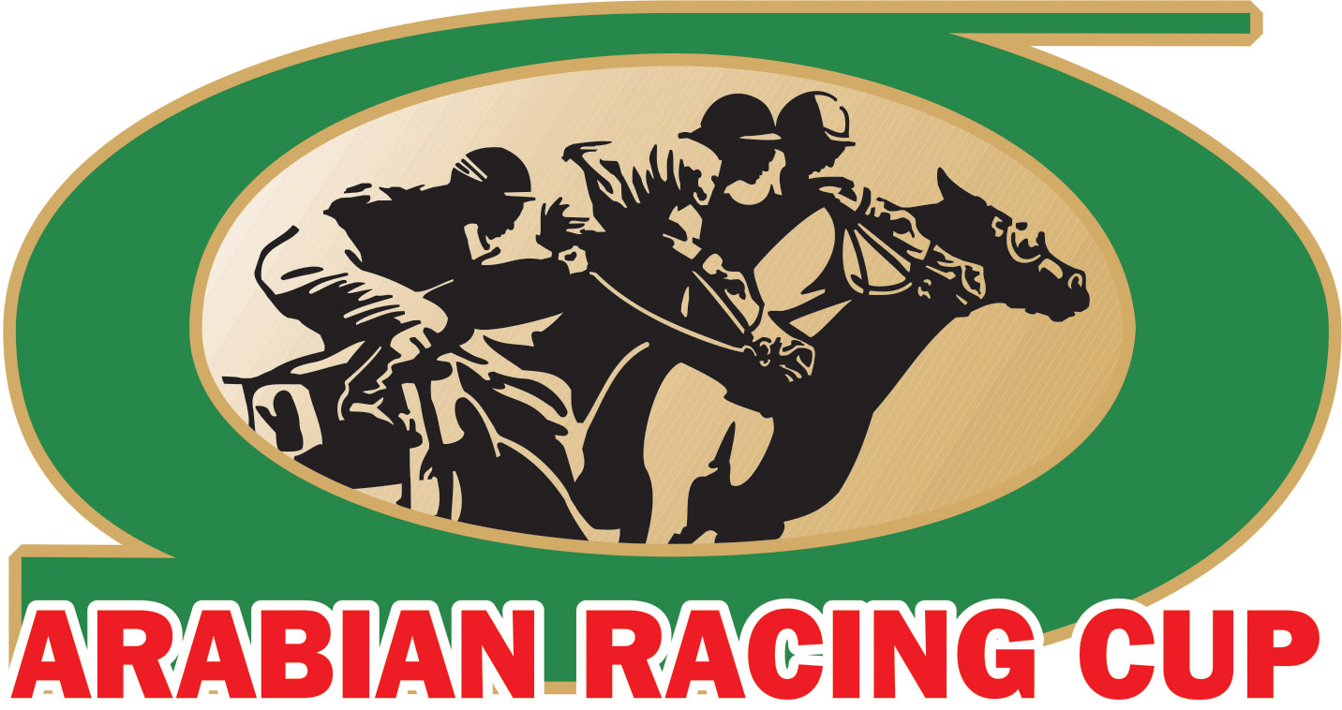
FOR IMMEDIATE RELEASE
Contact: Evie Tubbs Sweeney
(260) 348-1492

Nearly $20,000 Raised in 2020 ARC Darley Award Stallion Auction Benefitting the ARC Breeders Incentive Program

Smyrna, DE – The 2020 Darley Awards will go down in history as the first Darley Awards ceremony to be delivered virtually in the 33 years of the event’s heralded existence. Originally scheduled to be held in Houston on March 21st, the event was canceled just eight days prior as COVID-19 (coronavirus) concerns escalated and a worldwide pandemic was declared. Arabian Racing Cup (ARC) event team members pivoted to a new plan: Creating the first-ever Virtual Darley Awards event using social media technology to bring the Arabian racing community together.

The annual ARC Stallion Auction – a mainstay event of the Darley Awards each year – also likewise pivoted from a live auction to an online auction for the first time in its near 30-year history. A total of $18,950 was raised from eight leading Arabian racehorse sires:
- AF Albahar | Donated by Al Jeryan Stud. Sold to Abdallah Naili.
- Gazwan | Donated by Al Shahania Stud. Sold to Abdallah Naili.
- Grilla | Donated by Love ‘N War Arabians. Sold to Uptown Arabians.
- Hilal Al Zaman | Donated by Al Nujaifi Racing. Sold to Rita DeLeon.
- Majd Al Arab | Donated by Haras du Grand Courgeon. Sold to Uptown Arabians.
- RB Nash | Donated by RoseBrook Farms. Sold to Rita DeLeon.
- Seraphin Du Paon | Donated by Al Asayl Racing. Sold to Abdallah Naili.
- Sir Bani Yas | Donated by Al Asayl Racing. Sold to Abdallah Naili.

The highest lot was claimed by Madj Al Arab for $4,500. All proceeds benefit the ARC Breeders Incentive Program, which pays out additional monies (between $18,000 and $20,000) each year to breeders in every USA state.

“We’d like to take this opportunity to extend our thanks to each stallion owner who donated a breeding once again this year,” said Jon Henningsgard, ARC Chief Steward. “Even when COVID-19 forced us to pivot to an online format one week before the auction, we appreciated not only the owners’ willingness to be flexible, but also the winning bidders who participated from around the world to make this year’s auction successful, thereby contributing to the health of breeding in the United States through funds benefitting the ARC Breeders Incentive Program.”

The Darley Awards, along with the ARC Stallion Auction, will return to Houston, Texas in 2021.

####

The Arabian Racing Cup is a non-profit corporation founded in 1983 by Dr. Sam Harrison and run by its distinguished Board of Stewards, The Cup is dedicated to the national and international promotion of breeding and racing purebred Arabian horses. Launched in 1987, the Darley Awards are the crowning jewel of the Arabian Racing Cup, recognizing the most outstanding racehorses, jockeys, owners and breeders of the Arabian horse community in the United States. For more information, visit www.ArabianRacingCup.com

